


ΑΡΙΣΤΟΤΕΛΕΙΟ
ΠΑΝΕΠΙΣΤΗΜΙΟ
ΘΕΣΣΑΛΟΝΙΚΗΣ

 | 

Workshop
Γλωσσική εκπαίδευση σε δίγλωσσους μαθητές
Language Education for Bilingual learners

14 Ιανουαρίου 2012 | January 14, 2012
ΚΕ.Δ.Ε.Α | Aristotle University Research Dissemination Center

program

8.30-9.00
Registration

9.00-9.15
Opening note by Prof. Ianthi Tsimpli, Chair of the School of Modern Greek Language

9.15-9.30
Opening note by Dr. Anthi Revithiadou, Project Leader of ‘Reinforcement of the Mother Tongue’, Education of Immigrant and Repatriate Students

9.30-10.00
Rosemary Tracy (University of Mannheim)
Educating knowledge societies: How much linguistics should make its way into childhood education systems

10.00-10.30
Sharon Unsworth (Utrecht University)
Foreign Languages in a Primary school Project: Assessing early English in the Dutch primary school classroom

10.30-11.00
Florence Myles (University of Essex)
Comparing 5, 7 and 11 year olds learning French in the classroom in the UK

Coffee break: 11.00-11.30

11.30-12.00
Pedro Guijarro-Fuentes (Plymouth University)
The linguistic impact of the inductive vs. deductive instruction on L2 Spanish young learners’ grammars

12.00-12.30
Monika Rothweiler (University of Bremen)
Training preschool teachers in the domain of language and language acquisition: Results from an advanced-vocational-training study

12.30-13.00
Aoife Ahern (Universidad Complutense)
English language as a medium for developing collaboration and constructive interaction in upper primary school

Lunch break: 13.00-14.30

14.30-15.00
Despina Papadopoulou & Alex Tantos (Aristotle University of Thessaloniki)
Teaching Greek as a second language to young learners: The compilation of the Greek Learner Corpus

15.00-15.30
Marina Mattheoudaki & Thomai Alexiou (Aristotle University of Thessaloniki)
Tracking learners’ L2 development in a CLIL teaching context: Preliminary insights and suggestions

Coffee Break: 15.30-16.00

16.00-17.00
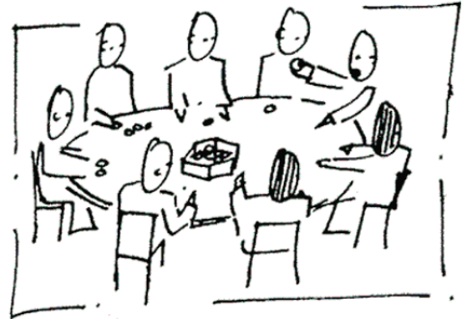 | Round Table Discussion  How to test and what to test in young instructed foreign (or native) language learners?

